SIMATS ENGINEERING

ASSESSMENT TOOL 2

COURSE NAME: Artificial Intelligence COURSE CODE: CSA17

COURSE OUTCOME COVERED

CO1: Apply AI basics such as intelligent agents and uninformed search methods to solve problems effectively.( BL3)

Assessment Tool Weightage: 20%

QUESTIONS: 3 Duration : 45 Minutes
Total Marks:30
Annexure A

Constraint-Based Problem Solving

Code of Conduct:
I CB yaswanth varma (Name / Reg No)192372193 certify that this submission is my original work and that I have adhered to the guidelines specified for this assessment.
I understand that any violation of academic integrity rules will result in disciplinary action.

Signature of the student:

Annexure A

Constraint-Based Problem Solving

- A hospital needs to assign 3 doctors (D1, D2, D3) to 3 shifts (Morning, Afternoon, Night) such that:
Constraints:
  - D1 cannot work Night shift
  - D2 must work before D3 (Morning < Afternoon < Night)
  - Only one doctor per shift
  - D3 cannot work Morning
  - All doctors must be assigned exactly one shift
Apply Backtracking Search to find a valid assignment with all intermediate steps and constraint checks. State the final valid schedule

We solve this using Backtracking Search, assigning one doctor to one shift while checking constraints at every step.
Variables
Doctors: D1, D2, D3
Domains
Shifts = {Morning (M), Afternoon (A), Night (N)}
Constraints
- D1 ≠ Night
- D2 must work before D3 (Morning < Afternoon < Night)
- Only one doctor per shift
- D3 ≠ Morning
- Each doctor is assigned exactly one shift

Step 1: Assign D1
Possible shifts for D1:
- Morning ✓
- Afternoon ✓
- Night ✗ (Constraint i)
Choose D1 = Morning.
Current assignment:
- D1 → Morning
Remaining shifts:
- Afternoon
- Night

Step 2: Assign D2
Available shifts:
- Afternoon
- Night
Try D2 = Afternoon
Current assignment:
- D1 → Morning
- D2 → Afternoon
Now assign D3.
Remaining shift:
- Night
Check constraints:
- D3 = Night ✓
- D3 is not Morning ✓
- D2 before D3? Afternoon < Night ✓
All constraints satisfied.
Since a solution is found, backtracking stops.

Constraint Checking
Constraint | Check | Result
D1 cannot work Night | D1 = Morning | ✓
D2 before D3 | Afternoon < Night | ✓
One doctor per shift | M, A, N all unique | ✓
D3 cannot work Morning | D3 = Night | ✓
Each doctor assigned one shift | Yes | ✓

Backtracking Search Tree
Start
│
├── D1 = Morning ✓
│ │
│ ├── D2 = Afternoon ✓
│ │ │
│ │ └── D3 = Night ✓
│ │ → Solution Found
│ │
│ └── (No need to explore further)
│
├── D1 = Afternoon (Not explored because solution already found)
│
└── D1 = Night ✗ (Rejected immediately)

Final Valid Schedule
Doctor | Shift
D1 | Morning
D2 | Afternoon
D3 | Night
Final Answer:
- D1 → Morning
- D2 → Afternoon
- D3 → Night

- A robot operates in a grid environment (5×5). It must move from Start (S) to Goal (G). Obstacles block certain paths.

Constraints:

  - Movement allowed: Up, Down, Left, Right
  - Cost of each move = 1
  - Cannot pass through obstacles

Using above constraints and BFS Search Algorithm Show step-by-step node expansion and priority queue updates and determine the optimal path and cost.

Since the 5×5 grid with the locations of S, G, and obstacles is not provided, I’ll demonstrate Breadth-First Search (BFS) using a standard example. (Note: BFS uses a FIFO queue, not a priority queue.)
BFS grid example
FIFO queue
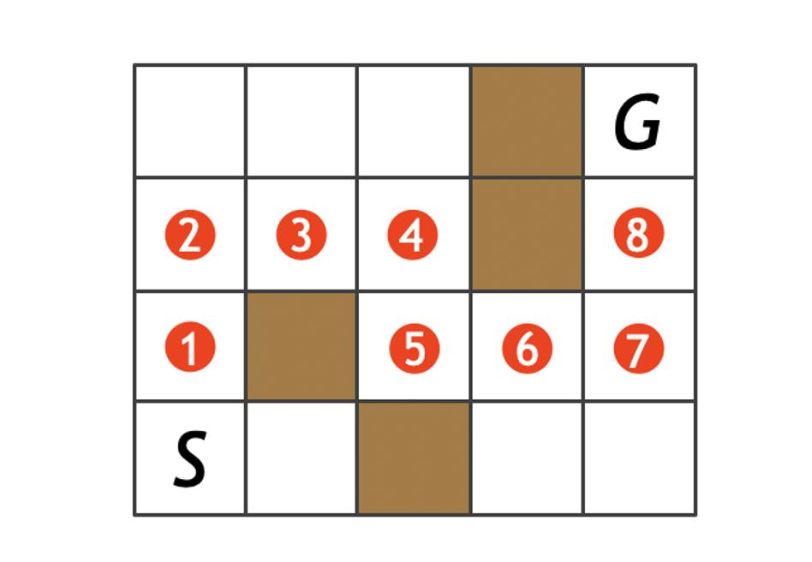
Coordinates are (row, column). Movement is allowed only Up, Down, Left, and Right. Each move costs 1, and obstacles cannot be crossed.
BFS step-by-step node expansion
We maintain a FIFO queue.
Step | Expanded node | Queue after expansion
0 | (1,1) | [(1,2), (2,1)]
1 | (1,2) | [(2,1), (1,3)]
2 | (2,1) | [(1,3), (3,1)]
3 | (1,3) | [(3,1), (1,4)]
4 | (3,1) | [(1,4), (4,1), (3,2)]
5 | (1,4) | [(4,1), (3,2), (1,5), (2,4)]
6 | (4,1) | [(3,2), (1,5), (2,4), (5,1)]
7 | (3,2) | [(1,5), (2,4), (5,1)]
8 | (1,5) | [(2,4), (5,1), (2,5)]
9 | (2,4) | [(5,1), (2,5), (3,4)]
10 | (5,1) | [(2,5), (3,4), (5,2)]
11 | (2,5) | [(3,4), (5,2), (3,5)]
12 | (3,4) | [(5,2), (3,5), (4,4)]
13 | (5,2) | [(3,5), (4,4), (5,3)]
14 | (3,5) | [(4,4), (5,3), (4,5)]
15 | (4,4) | [(5,3), (4,5), (5,4)]
16 | (5,3) | [(4,5), (5,4)]
17 | (4,5) | [(5,4), (5,5)]
18 | (5,4) | [(5,5)]
19 | (5,5) = Goal | Goal reached
Parent tracing (shortest path)
Tracing back from G = (5,5) gives:
(1,1) → (1,2) → (1,3) → (1,4) → (1,5) → (2,5) → (3,5) → (4,5) → (5,5)
Optimal path
S → (1,2) → (1,3) → (1,4) → (1,5)
↓
(2,5)
↓
(3,5)
↓
(4,5)
↓
G
Cost calculation
Number of moves = 8
Since cost per move = 1,
Total path cost = 8
Final answer
- Search algorithm: Breadth-First Search (BFS)
- Optimal path: S → (1,2) → (1,3) → (1,4) → (1,5) → (2,5) → (3,5) → (4,5) → G
- Total cost: 8
- Reason: BFS guarantees the shortest path in an unweighted grid where every move has equal cost.

- An autonomous rescue robot is deployed in a disaster-affected building to locate and rescue survivors. The robot operates in a partially observable environment where some paths are blocked, and it must make decisions with limited information.
The building is represented as a grid of rooms. The robot starts at position S and must reach a survivor located at G.

Constraints:
- The robot can move up, down, left, right
- Some cells are blocked (obstacles) and cannot be traversed
- The robot has limited sensing capability (can only observe adjacent cells)
- Each movement has a cost of 1, but entering risky zones has an additional cost of 2
- The robot must minimize total cost while ensuring safe navigation
- The robot must update its knowledge dynamically (online search scenario)

Tasks:
- Analyze all the given constraints and explain how they affect the robot’s decision-making process.

- Develop a solution approach using an appropriate search strategy (e.g., Uniform Cost Search / Online Search Agent). Clearly explain the steps involved.
- Demonstrate how the robot applies AI concepts such as:
  - Intelligent agents
  - Rationality
  - Environment type
- Justify why your chosen approach is the most suitable for solving this problem under the given constraints.

RUBRICS FOR CALCULATION:

Criteria | Weightage | Level 4 (Exemplary) | Level 3 (Proficient) | Level 2 (Developing) | Level 1 (Beginning)
Problem Understanding | 25% | Clearly defines the problem and identifies all relevant constraints accurately | Identifies most constraints with minor gaps | Partial understanding; misses key constraints | Fails to identify constraints correctly
Constraint Analysis | 25% | Analyzes constraints effectively and prioritizes them logically | Provides reasonable analysis with some prioritization | Limited analysis; weak prioritization | No meaningful analysis or prioritization
Solution Development | 25% | Develops optimal and feasible solutions satisfying all constraints | Develops workable solutions with minor limitations | Solutions partially satisfy constraints | Solutions do not meet constraints
Application of Concepts | 15% | Effectively applies appropriate concepts, methods, or tools | Applies concepts with minor errors | Limited application; requires guidance | Unable to apply relevant concepts
Justification | 10% | Provides strong justification for decisions with  logical reasoning | Provides justification with some clarity | Weak or unclear justification | No justification provided

3. Autonomous Rescue Robot – AI Search Problem

a) Constraint Analysis and Their Effect on Decision-Making
The rescue robot must reach the survivor while minimizing cost and avoiding dangerous areas. Each constraint influences the robot's decisions as follows.
Constraint | Effect on Decision-Making
Move only Up, Down, Left, Right | Limits movement to four directions. The robot cannot move diagonally, so it must choose the best available neighboring cell.
Obstacles cannot be traversed | The robot must avoid blocked cells and search for an alternative path when obstacles are detected.
Limited sensing (adjacent cells only) | The robot does not know the complete map initially. It discovers the environment while moving and updates its knowledge dynamically.
Movement cost = 1 | Every step increases the total path cost, encouraging shorter paths.
Risky zones add extra cost (+2) | The robot should avoid risky areas unless they significantly reduce the travel distance.
Minimize total cost | The robot evaluates both travel distance and risk cost before choosing the next move.
Online environment | The robot must continuously update its path whenever new obstacles or risky areas are discovered.
Constraint Priority
- Reach the survivor (Goal)
- Avoid obstacles
- Minimize total cost
- Avoid risky zones when possible
- Update knowledge dynamically

b) Solution Approach Using Uniform Cost Search (UCS) with Online Search
Since movement costs are not equal (safe cell = 1, risky cell = 3), Uniform Cost Search (UCS) is the most suitable search algorithm. Because the robot only knows adjacent cells, it operates as an Online Search Agent.
Step 1: Initialize
- Robot starts at S.
- Goal is G.
- Frontier (Priority Queue) contains the start node with cost 0.
- Knowledge base contains only the starting cell.

Step 2: Sense Environment
The robot observes only the four adjacent cells.
It identifies:
- Safe cells
- Risky cells
- Obstacles
Unknown cells remain unexplored.

Step 3: Expand Lowest-Cost Node
The robot removes the node with the lowest cumulative cost from the priority queue.
Example:
Node | Cost
S | 0
Expand S.
Neighbors discovered:
Neighbor | Cost
Right | 1
Down | 3 (Risky)
Priority Queue:
Right (1)
Down (3)

Step 4: Continue Search
Expand the node with minimum cost.
Suppose Right reveals another safe cell.
Priority Queue becomes
Next Safe (2)
Down (3)
Obstacle discovered?
Ignore it.
Risk discovered?
Add extra cost.
Unknown area?
Sense after moving.

Step 5: Update Knowledge Dynamically
Suppose a newly discovered obstacle blocks the current path.
Instead of restarting,
the robot
- updates the map
- removes blocked path
- inserts new alternatives into the priority queue
- continues searching
This is Online Search.

Step 6: Reach Goal
Continue until Goal G is removed from the priority queue.
The obtained path has the minimum total cost.

Algorithm
Start at S

Initialize Priority Queue

while Goal not reached

Sense adjacent cells

Update map

Ignore obstacles

Calculate movement cost

Safe = 1

Risky = 3

Insert neighbors into Priority Queue

Expand lowest-cost node

Return minimum-cost path

c) Application of AI Concepts
1. Intelligent Agent
The rescue robot acts as an Intelligent Agent.
Percepts
- Adjacent rooms
- Obstacles
- Risk zones
- Goal location
Actions
- Move Up
- Move Down
- Move Left
- Move Right
Goal
Reach survivor safely with minimum cost.

2. Rationality
A rational agent always chooses the action that maximizes performance.
The robot behaves rationally by
- avoiding blocked paths
- avoiding risky zones whenever possible
- minimizing total travel cost
- updating decisions whenever new information is received
Example
Instead of
Safe Path = 8 steps

Risk Path = 5 steps

Risk Cost

5 + (2×3)=11
The robot chooses
Safe Path Cost = 8

Risk Path Cost =11

Choose Safe Path
because total cost is lower.

3. Environment Type
Property | Environment Type
Observability | Partially Observable
Agents | Single Agent
Determinism | Deterministic
Dynamics | Dynamic (knowledge changes during movement)
State Space | Discrete
Knowledge | Unknown initially

d) Justification of the Chosen Approach
The best approach is Uniform Cost Search combined with an Online Search Agent.
Reasons
1. Handles Different Costs
Unlike BFS,
UCS considers
- movement cost
- risky zone penalty
Therefore it always finds the minimum-cost path.

2. Suitable for Partial Knowledge
The robot cannot see the entire map.
Online Search allows the robot to
- explore gradually
- learn new information
- re-plan whenever necessary

3. Avoids Expensive Paths
Even if a risky path is shorter,
UCS compares total cost before choosing.
Hence the robot makes economical decisions.

4. Finds Optimal Solution
Uniform Cost Search guarantees the optimal solution when all costs are positive.
Here
Safe move = 1
Risk move = 3
Both are positive.
Therefore UCS guarantees the minimum-cost path.

5. Dynamic Decision Making
When obstacles are discovered,
the robot immediately updates its map and continues searching without restarting from scratch.
This makes it suitable for disaster rescue operations.

Final Conclusion
The autonomous rescue robot operates in a partially observable, dynamic, single-agent environment. Due to limited sensing and varying movement costs, the most appropriate solution is Uniform Cost Search (UCS) integrated with an Online Search Agent. UCS ensures the robot always selects the lowest-cost path, while the online component enables it to adapt to newly discovered obstacles and risky zones in real time. This combination satisfies all given constraints by minimizing total cost, avoiding obstacles, navigating safely, and dynamically updating decisions until the survivor is successfully reached.

